Philco 102 Communication Processor

Built for DCA/DISA in 1962 by Philco-Ford Plant 50

System provided for the AUTODIN program

Paper authored by Tino Randall in the Year 2022.

---------------------------------------------------------

I did some research on the 102 processor but could not locate any information over the Internet or technical databases. It’s probably because the 102 processor design and operation were termed, at its time (1962), highly classified for use of U.S. Defense and Military intelligence.

Declassified since the termination of AUTODIN (Automatic Digital Network), at this time (2022), I felt it appropriate to provide some information for the system that employed thousands of civilians, civil services, and military personnel over a period of the 45 plus years, its ground-based operational lifespan. Although the 102 Processor was still termed as Mainframe Computer system, it contained several innovations not well known to the outside world, then and now. Designed by PhD’s, built by engineers at Bell Labs and manufactured by Philco-Ford, the 102 was redesigned from the original Philco-Ford Model 1000 (prototype) that was never deployed into the industries. However, it provided innovations no other computer manufacturer had back in the early 60s.

On a more personal note, after arriving in the States in 1961 from Germany, my first and foremost ambition was to seek employment at the once prestige’s Bell Labs. Unfortunately, my application was turned down for one reason: *Your credentials are not sufficient for hiring.* What it meant was, I did not have high enough credentials working alongside 2,000 PhD’s that made up the staff in addition to countless engineers and support teams. In hindside, my career turned out far better than expected. Checking in with Bell Labs years later, I’d learned that they were on the brink of bankruptcy. What saved their existence was AT&T, who bought what was left of the laboratory, one PhD still employed.

What transpired that drove Bell Labs into extinction was the U.S. government, specifically the department of defense. With DOD under new directorship and strategic defense initiatives, the bulk of PhD’s was forced into taking positions with national laboratories and government research facilities, their only options for employment.

Although ten major computer manufacturers the likes of Westinghouse, IBM, Burrows, Univac, NCR, and others were bidding on the AUTODIN system to be build, what made the 102 processor unique were its innovative design features. Though I was not part of the design and its manufacturing process, I was trained on the Model 1000 at the college I attended providing an insight view into its design features.

With the AUTODIN program launched in 1962, it took four years to build hardware, software and system components to become operational in 1966, my entry into the mysterious world of military and defense intelligence. It was also the time I became intricately familiar with the system’s hardware, software, configuration and operations.

Whereas up until the 60s, all mainframe computers were *synchronous* systems, the 102, in contrast, was the first *asynchronous* designed computer with unique design differences as follows:

* Asynchronous data processing
* Predictive adder network computation
* Rotating scanner processing
* Time-slice data delivery

SPECIFICS

*Synchronous vs. Asynchronous operation*

Up until the 102 computer design, all Mainframes in the world (U.S. and Japan) were of synchronous design where each and every processing step was triggered by an internal clock timed at an approx. 200 milli-second speed. Which meant that every internal processing step had to wait until the previous step was completed before moving on (clocked) to the next data processing function. With asynchronous data processing, it all changed. The entire system was designed without being clocked, equating to an operational speed linked to the internal switching time of the “surface-barrier” based transistor, built by Philco, at about 10 nano second switching speed, a ten-thousand fold processing speed increase.

*Predictive Adder Net computation*

Much like the human body, the computer has a pulsing heart as its center of existence, namely, the adder network. Each and every operational step the computer takes is moved through the adder network comprised of internal data registers fed by two input binary data sets with one resultant data output register, typically the size of either 16, 24, 32, 48, 96 and more data bits in lengths, depending on the size of the processor. The 102 was designed with 32 bit data, and 16 bit address and index registers.

The way it works: one operating software instruction at a time is pulled from the external database or internal memory to retrieve the contents of the address, then shifted into the adder where it is combined with a second data set to produce the desired result converter from digital binary to readable character information.

Typical numeric example: 10 x 10 = 100

Typical alpha character example: Tino Randall + Employment = Philco Ford

With synchronous computers, binary data is fed by both input registers into the adder network, shifted through each state one bit at the time to obtain the output result. With the removal of the internal clock, asynchronous processing speed not only increased ten-thousand fold, the predictive feature, in addition, sensed the resultant output data by scanning the two input data registers before it was ever computed by the adder, thus adding to the processing speed.

*Rotating Scanner processing*

To speed up processing even more, a digital scanner was designed and built into the Computer Interface Assembler (CIA) section of the processor. To get the true picture, one must understand that each AUTODIN Site was configured and operating with five 102 Processors identical in size and design, but serving various operational functions.

The functional differences were as follows:

1. Master Processor (MP)
2. Standby Processor (SP)
3. 4 slave Processors designated Line Termination Controllers (LTC)

The principle design feature was for the SP to automatically switch into the configuration, if and when one of the computers failed to take over its function. Also, each computer was programmed to take over every other computer function in the site configuration.

In case of equipment failure, to achieve the various operational states, current data and information was loaded in parallel fashion into the standby computer through the CIA interface ready to take over its function in seconds. It was the digital scanner that continuously monitored each computer for operational state (ghosting), continuously updating current and live data and information.

*Time-slice Data delivery*

The purpose for the LTC was to send processed information to Comm and Tech Control sections where the digital data was converted to analog format and sent on to the final section, the Crypto room for encryption. From there, information exited the building, transmitted either to the Pentagon, White House, Central Intelligence Agency (CIA), Military command and control centers, Military and Intel subscribers (users) wherever we had a military presence in foreign countries, as well as U.S Embassies around the globe.

Processed data, back then, were messages much like Email and Texting in today’s world, but highly classified and mission critical. Whereas with *synchronous* processing, data was sent to the outside world over one channel at the time presenting slow message deliver. With Time-slice delivery, the Computer Interface Assembler (CIA) segmented streams of information (one data character at a time), were shipped simultaneously through 250 channels (subscribers) at the same instance, much like a sprinkler system watering the entire yard.

One might ask, what system replaced such an innovative AUTODIN design?

Over the cause of 45 plus years, AUTODIN underwent numerous integrations, upgrades, and enhancements in a technological runaway epoch. First, there was the Pacific upgrade in 1972, where pacific AUTODIN sites gained a fifth computer system. Because of a rapid and urgent deployment and installation schedule, with the Vietnam war ramping up and Korea tensions escalating, the initial 4 Pacific sites had a reduced computer system configuration until additional 102 Processors became available.

Next, the following year 1973, came the first Processor upgrade to all sites. Up to this time, in case of a system failure, the recovery computer configuration had to be performed through manual switch intervention executed by the chief of operation, taking many minutes of downtime. It meant that the entire U.S. military and intelligence communication in that specific country was inoperative until the 102 system was reestablished. The upgrade involved an additional central processing panel termed Scratch Pad, designed by Pete Baker and Al Urban with software developed by Pete Powilleit. Its sole purpose was to completely automate the manual configuration process, executed within seconds.

The following year, 1974, an important one, saw another hardware implementation. It added an entire complement of external memories from 4 to 8 banks to the central processor configuration, thus decreasing data throughput and delivery time even more. This and the previous upgrades were of critical importance. It was a time of chaotic escalation with the Vietnam War, where the AUTODIN design capability performed flawlessly, ultimately tested to its limits. The system had proved its worthiness.

A couple of years later, new front-end computers, the Digital Equipment’s DEC PDP 11-84 communication processor, replaced the outdated LTC mainframe system, quickly followed by the DEC VAX 11-780, a business style processing system to perform an ever-increasing work load of message preparation, accounting, scheduling, and more offline computer activities.

It was in the late 70s when a major communication technology leap took place. It was a time to move communication systems, ground-based until then, into space. The age of Satellite communication had arrived. From here on, technology changes developed so rapidly that it took two (10-member) crews to implement upgrades around the globe (14 Intel sites overseas).

The following decade, the 80s brought on new challenges. When rumors leaked out to the nation about AUTODIN with its wonders, national laboratories and major universities demanded the system or something equivalent. To satisfy the growing demands, other computer manufacturers were given the opportunity to build similar systems. Since AUTODIN was classified Top Secret, national security became an issue. To solve the challenge, the government provided a downgraded transmission protocol for public use, the Advanced Research Projects Agency (ARPANET).

It was not until the early 90s when the general public became aware of AUTODIN, brining on more changed. For that to happen, five major element came together:

1. IBM invented the Personal Computer (PC)
2. Intel manufactured the microprocessor
3. Microsoft developed Windows 95
4. DARPA provided an unclassified interface protocol, the TCP/IP
5. The modern-day Internet was born.

In the initial year that followed, only Computer Geeks like myself, took to the Internet. To gain access to the net, one had to visit the computer store, acquire all necessary computer components, assemble it into a box, lease a dedicated telephone line, ( in my case a T-1 at a $2k/month fee, make the connection, purchase a copy of Windows 95 in a software store and roam the Internet for a computer game.

Yes, there were a few games already being developed in Japan, but not yet for computers. It was for video screen gaming machines making their appearances at gaming parlors. The Geeks had to wait a few months more for the first computer based games, PACMAN, followed quickly with Mario Brothers, and Maze.

Ever since, the world has dramatically changed affecting personal lives. Where up to that time public recreation was mostly spent reading books, with the young taking part in kicking the can, playing Cowboys and Indians, learning the skills of the Yoyo or Hula-hoop and other activities, in today’s world, it seems that many are entranced or entrapped into a virtual world of computer generated action, not allowing much time for leisure we used to know.

Where AUTODIN in 1962 was an inception created by president John F. Kennedy, it served the U.S. Government well beyond its designed expectations. Unfortunately, he did not see his visions, AUTODIN nor Space Exploration to the Moon accomplishments. Turned over to the public in 1995 as Internet, it caught on like wildfire propagating throughout the globe. It became the invention of the Century, directing and dictating most of our waking moments.

Was it a good thing?

You decide!

The future will ultimately hold the answer.

tlr.

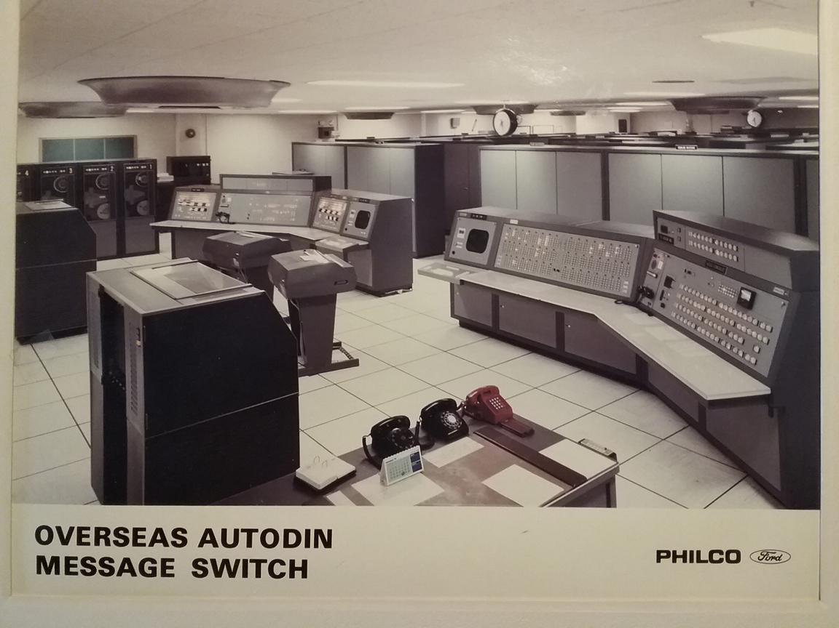

AUTODIN System – 102 Processor Cabinets in Background

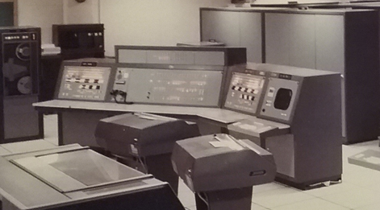

AUTODIN 102 Processor - OPS/Maintenance Console

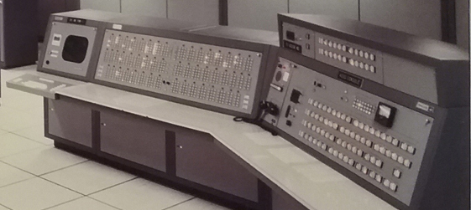

AUTODIN 102 Processor - Monitor Console